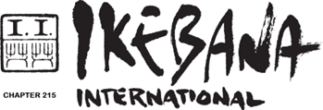

REGISTRATION FORM
I hereby apply for membership of Ikebana International Nederland, Chapter #215
(for 65 euros per year).

Family name: First name:

Adress/postal code: Place:

Country: Date of birth:
Phone/mobile : E-Mail:

Ikebana school:

In accordance with privacy laws (General Data Protection Regulation)
choose one of the options in the following statements:
I agree / do not agree to I.I. providing my personal information to other members
for ikebana purposes only.

I agree / do not agree to I.I. posting pictures of myself in our Sakura news,
website and social media.

I agree / do not agree to I.I. posting pictures of my arrangements
in our Sakura news, website and social media.

I agree / do not agree to I.I. making use of pictures made by me
in our Sakura news, website and social media.

I agree / do not agree with forwarding by I.I. of pictures made by me
at the request of third parties.

 I hereby agree that any and all documents relating to the General Meeting of Ikebana International, including the convocation notice with proxy, will be sent to me by electromagnetic means such as sending email and posting on the I.I. web site.

Signature: Date:

Mail this form to: i.i.treasurer215@gmail.com

Payment of the membership fee to the treasurer Hermien Schuurmans:
IBAN NL58 ABNA 0431 8400 24 in the name of
The Netherlands Chapter of Ikebana International
BIC ABNA NL2A (for transfer from abroad)

